CMPT 310 Assignment 3

Junchen Li

301385486

2021/3/24

**Question 1**

KB = {$C(Alice)$ $C(Bob)$ $C(Christine)$ $∀x (C\left(x\right)∧ ¬ S\left(x\right)⊃M(x))$

$∀x (M\left(x\right)⊃ ¬ L(x,rain))$ $∀x \left(¬ L\left(x,snow\right)⊃¬S\left(x\right)\right)$

$∀x ( L\left(Alice,x\right)⊃¬L(Bob,x))$ $∀x (¬L(Alice,x) ⊃ L(Bob,x))$

L(Alice, rain) L(Alice, snow) }

We need to prove the statement : $∃x [C\left(x\right)∧M(x)∧¬S(x)]$ That is the query as well.

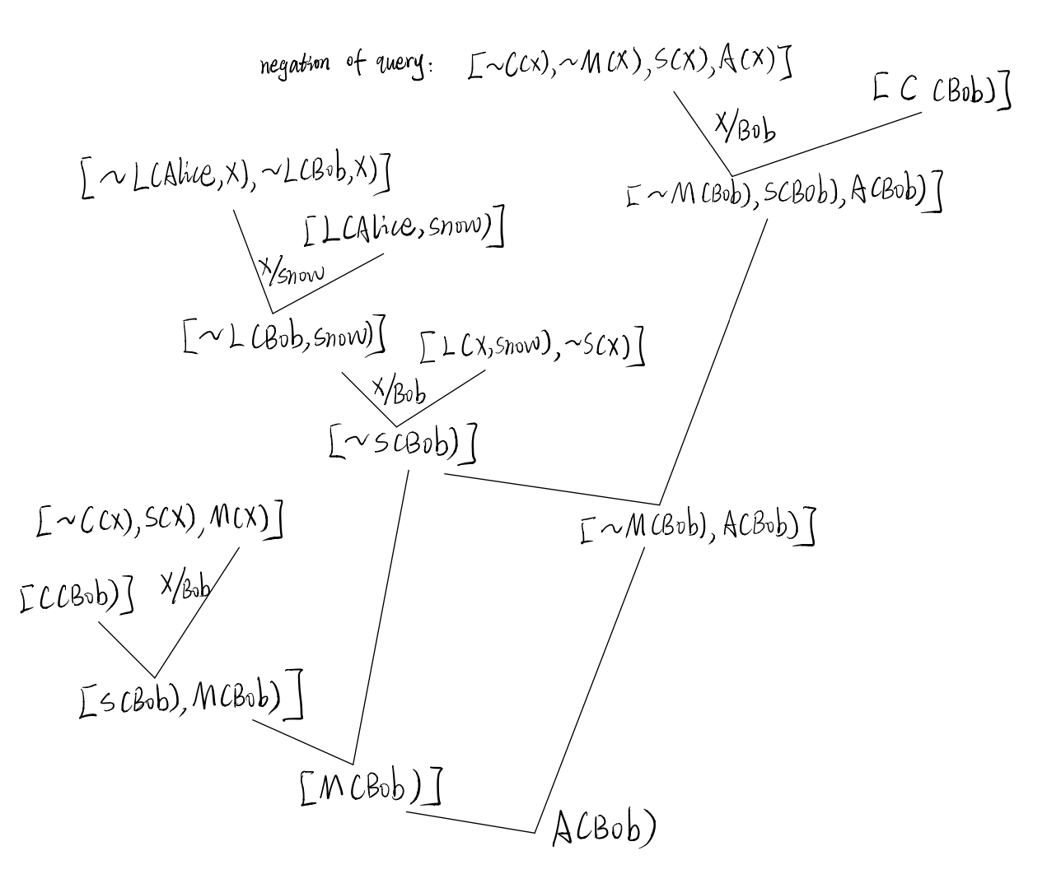Negation of this query: 🡪 [ ~C(x), ~M(x), S(x) ]

Follow the above process, we can get Bob is the person who is member in Alpine Club and he is a mountain climber but not a skier. For the Christine, we do not have enough information to determine his feeling about everything.

The KB’ part as follow:

KB’ = { $C\left(Alice\right),$ $C(Bob)$, $C(Christine)$, $∀x (C\left(x\right)∧ ¬ S\left(x\right)⊃M(x))$

$∀x (M\left(x\right)⊃ ¬ L(x,rain))$ $,∀x \left(¬ L\left(x,snow\right)⊃¬S\left(x\right)\right)$,

$∀x (L(Bob,x) ⊃¬ L(Alice,x))$, L(Alice, rain) , L(Alice, snow) }

The query is : $α= ∃x [C\left(x\right)∧M(x)∧¬S(x)]$

We need to show the *I $⊨α but I⊨KB'$.* Therefore, I make an interpretation I which can meet the above requirements.

*I* (C (x)) = {Alice, Bob, Christine} *I*(S(x)) = {Alice, Bob, Christine} *I*(M(x)) = {}.

*I* (L (x, y)) = {[Bob, rain], [Bob, snow], [Alice,rain], [Alice, snow], [Christine, snow], [Christine, rain]}.

In concluded, we know all three people are members in Alpine Club and it is trivially true that there is no member who is not a skier and there is a member who is a climber in KB’. We only know Bob like whatever Alice doesn’t like. And we only know Alice love rain and snow. So, we can set Bob love everything including rain and snow. (There isn’t have “Bob dislike whatever Alice like”). Therefore, these three people are skiers (loving snow) and Bob loves everything. The sentence $∃x \left[C\left(x\right)∧M\left(x\right)∧¬S\left(x\right)\right]$ cannot hold any more because of there are no climbers in this situation. And the interpretation I is a counterexample.

**Question 2:**

Start State: OP (Action: Start,

Effect: Clear(A) $∧$ Clear(B) $∧$ Clear(C) $∧$ on(A, T) $∧$ on(B, T) $∧$ on(C, T) )

Goal State: OP (Action: Finish,

Precord: on(A, B) $∧$ on(B, C) $∧$ on(C, T) $∧$ clear(A) )

OP(Action: Move (x,y,z)

Precond: on(x, y), clear(x), clear(z)

Effect: on(x,z), $¬clear(z)$, $¬on(x,y)$)

OP(Action: MoveToTable(x,y)

Precond: clear(x), on(x, y)

Effect: clear(y), $¬on(x, y)$)

1. 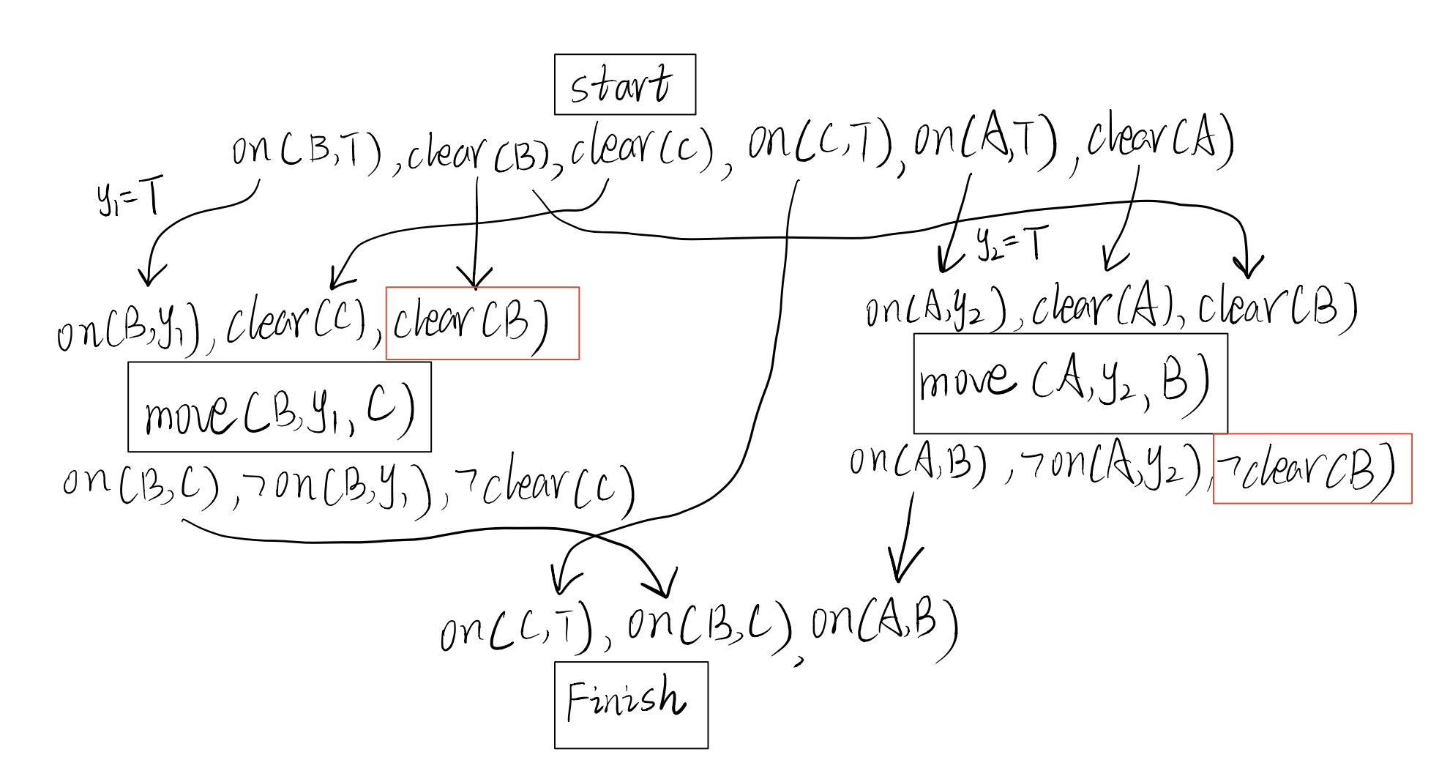

The partial plan that from first introducing Move(B, y1,C) and then Move(A, y2,B)  shown as above.

1. 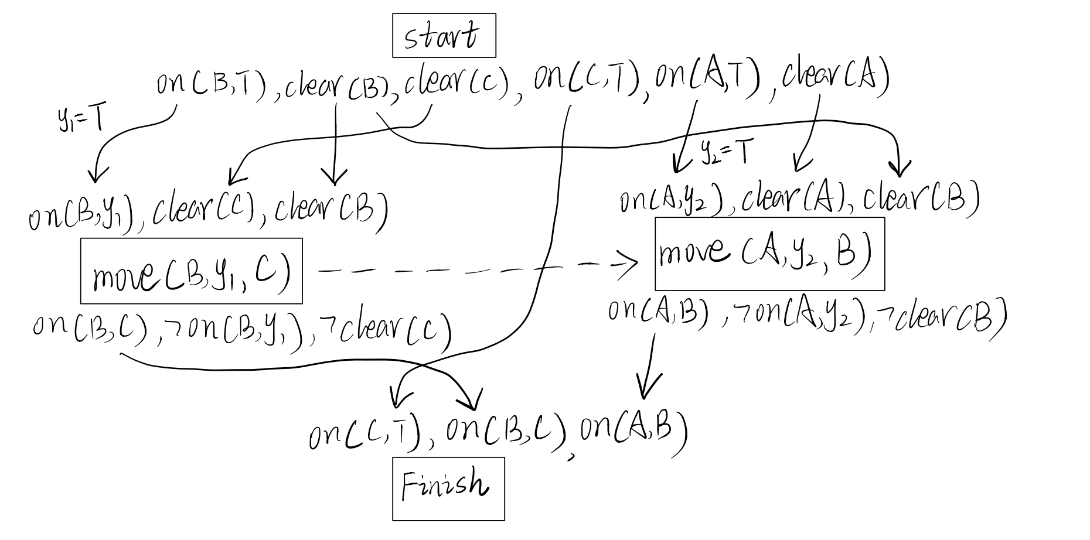It contains a conflict by circling precondition and effect pair. In the above plot the red circle shows that threat. The effect in move(A, y2,B) not meet the precondition of move(B, y1,C). So we need to add a causal link for showing the ordering. Following image is the resulting plan. Now, this plan is consistent and completely.

**Question 3:**

1. P(Q1| W) = 0.95

P(Q2| W) = 0.95

P(Q3| W) = 0.95

P(Q1| W) = 0.3

P(Q2| W) = 0.5

P(Q3| W) = 0.1

P(w) = $\frac{4}{5}=0.8$

1. **P(w|Q1)**

Answer: P($¬$ W) = 1-0.8 = 0.2 P(W|Q1) = $\frac{P\left(Q1 | W\right)P(W)}{P(Q1)}$

P(Q1) = Pr(Q1|W) * P(W) + P(Q1|W) * P($¬$ W)

= 0.95 * 0.8 + 0.3 * 0.2

= 0.76 + 0.06 = 0.82

$∴$ P(W|Q1) = $\frac{P\left(Q1 | W\right)P(W)}{P(Q1)}$ = $\frac{0.95*0.8}{0.82}$ = 0.92683.

**P (Q1, Q2| W)**

Answer: When given the “ $¬$ W”, the Q1 and Q2 are conditionally independent to each other. The probability of the second question was not affected by the correctness of the first question. So it is equivalent to P(X,Y|Z) = P(X|Z)*P(Y|Z).

P(Q1,Q2|W) = P(Q1|W) * P(Q2|W)

= 0.3 * 0.5 = 0.15

$∴$ P(Q1,Q2|W) = 0.15

**P(Q3|Q1, Q2, W)**

Answer: The probability of Q3 is conditionally independent with Q1 and Q2. Due to the formula: P(X|Z,Y) = P(X|Z). P(Q3|Q1,Q2,W) = P(Q3 | W) = 0.95.

$∴$ P(Q3|Q1,Q2,W) = 0.95.

1. **P (W|Q1, Q2, $¬$ Q3)**

Answer: Q1, Q2, Q3 are **conditionally independent** given W.

P($¬$ Q3|W) = 1 - P(Q3|W) = 0.05

P(W|Q1) = $\frac{P\left(Q1 | W\right)*P(W)}{P(Q1)}= \frac{0.95*0.8}{0.82}=0.9268$

P (W|Q1, Q2, $¬$ Q3) = $α*P\left(W\right)* P\left(Q1 | W\right)* P\left(Q2 | W\right)*(¬Q3|W)$

$$∵P\left(Y | X\right)= α*P\left(X | Y\right)*P(Y)$$

$$∴ α*P\left(W\right)* P\left(Q1 | W\right)=P(W|Q1)$$

P (W|Q1, Q2, $¬$ Q3) = $P(W|Q1)* P\left(Q2 | W\right)*(¬Q3|W)$

= 0.9268 * 0.95 * 0.05 = 0.044023

1. **P (W|Q1, $¬$ Q2, $¬$ Q3)**

Answer: Q1, Q2, Q3 are **conditionally independent** given W.

P($¬$ Q2|W) = 1 - P(Q2|W) = 0.05

P (W|Q1, $¬$ Q2, $¬$ Q3) = $α*P\left(W\right)* P\left(Q1 | W\right)* P\left(¬Q2 | W\right)*(¬Q3|W)$

$$∵P\left(Y | X\right)= α*P\left(X | Y\right)*P(Y)$$

$$∴ α*P\left(W\right)* P\left(Q1 | W\right)=P(W|Q1)$$

P (W|Q1, Q2, $¬$ Q3) = $P(W|Q1)* P\left(¬Q2 | W\right)*(¬Q3|W)$

= 0.9268 * 0.05 * 0.05 = 0.002317

1. Because of there is conditional independence between some variables, that is, the probability that any change in one factor does not affect the other. Example here, we want to get P(Q1|Q2). Although we have some mistakes for calculating Q2 in other question, the final result will not change. The Q1 and Q2 are conditional independent. So that’s the answer why does one correct or wrong answer not affect the chance for answering other question correctly.

**Question 4**

1. **P (W ∧ ¬L ∧ R ∧ S=spring  )**

Answer: W depends on R and L, R and L are independent. R & L also depend on S.

P (W ∧ ¬L ∧ R ∧ S=spring  ) = P(W|R∧¬L )* P(¬L|S) * P(R|S) * P(S)

= 0.95 * (1-0.15) * 0.45 * 0.25 = 0.0908

1. **P (S=winter | ¬R ∧ ¬L)**

Answer: Due to the R and L are conditional independent.

P(R) = P(R|S) * P(S) + P(R|¬S) * P(¬S)

= 0.2 * 0.25 + (0.35+0.15+0.45) *(1-0.25) = 0.05 + 0.7125 = 0.7625

P(¬R) = 1-0.7625 = 0.2375

P (S=winter | ¬R ∧ ¬L) = $α*P\left(S\right)* P\left(¬R | S\right)* P(¬L|S)$

$$∵P\left(Y | X\right)= α*P\left(X | Y\right)*P(Y)$$

$$∴α*P\left(S\right)* P\left(¬R | S\right)=P(S|¬R)$$

$P(S|¬R)$ = $\frac{P\left(¬R | S\right)*P(S)}{P(¬R)}$ = $\frac{\left(1-0.2\right)*0.25}{0.2375}=0.8421$

P (S=winter | ¬R ∧ ¬L)  = $P(S|¬R)$* P(¬L|S) = 0.8421 * (1-0) = 0.8421

1. **P(R|W ∧S=summer)**

Answer: If the season is summer then the P(R|summer) only have probability of 0.15. If the W is true and we use the third CPT table. We can see there are three high probabilities from four choices. And from top three choices, there are two choice implies that R is true. So we did simply calculation, we guess it at least greater than 0.5 because of ( $\frac{2}{3} ≈0.667$).

P(W|R) = 0.95*2/2 = 0.95

P(R|W ∧S=summer)  = P(W|R) * P(R) + P(R|S) *P(S) = 0.95 * 0.7625 + 0.15 * 0.25

= 0.7243 + 0.0375 = 0.7618.